**What is GUTI?**

**5G Global Unique Temporary Identifier** [5G – **GUTI**] is a core network temporary identifier and allocated by **Access and Mobility Management function**[**AMF**] to the **UE**.

* GUTI is 80 bits long core network identifier
* It is consist of major three network identities PLMN + AMF ID + TMSI
* It is a temporary identifier so it’s associations is not fixed to a specific subscriber or mobile
* Single 5G-GUTI can be used for accessing 3GPP and non-3GPP technologies security context within the AMF
* An AMF may re-assign a new 5G-GUTI to the UE at any time under specified conditions
* When the UE is in CM-IDLE, the AMF may delay in the assignment of a new
* 5G-GUTI until the next NAS transaction happens

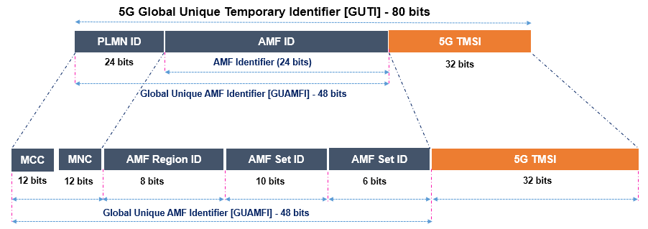

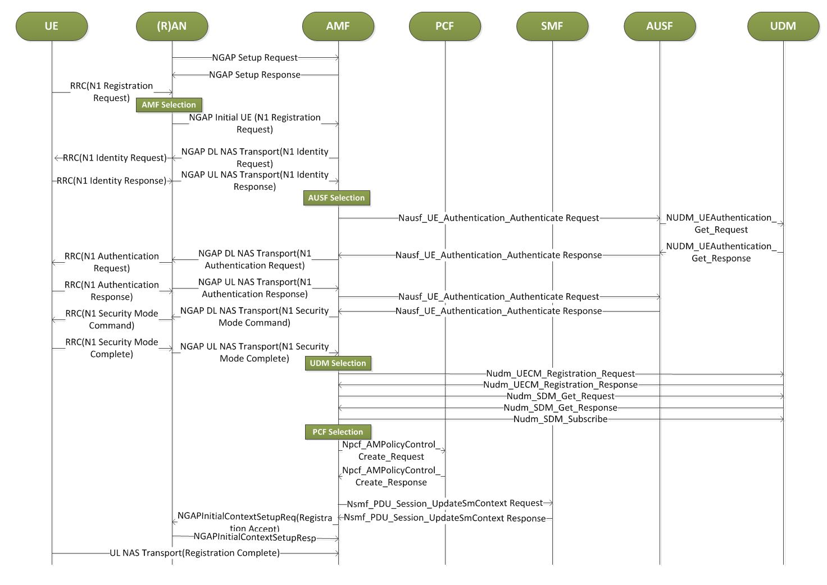

GUTI Registration steps

1.Registration Type-> Initial reg, Mobility Reg, Periodic Reg or Emergency reg

2.User Identity ->5G-GUTI, SUPI, PEI or 5G-GUTI derived from 4G GUTI for inter-working.

3.List of Visited TAI -> last visited TAI list

4.Security Capability-> Integrity and Encryption algos UE Supports.

5.Requested NSSAI -> Any preferred NSSAI on which UE want to camp on.

6.Default NSSAI indication -> If AMF can select default NSSAI if Requested NSSAI is not available.

7.UE Capabilities -> UE Radio capabilities and MM Capabilities.

8.PDU Session Status -> Previously connected PDU sessions under previous PLMN (3Gpp or Non 3Gpp)

9.List of PDU session need to be activated-> If there is some pending UL traffic for a PDU session then UE include that PDU session in the list of PDU sessions.

gNB select a AMF based on the 5G-GUTI(SUCI) or existing N2connection for the UE. Else it selects preferred AMF based on NSSAI, if SUPI or PEI are included.

After AMF selection, NG-RAN(gNB) forwards Registration request to MME piggybacking on NGAP Initial UE message.

If SUCI is not provided in Registration request or retrieved from old AMF then AMF sends Identity request message to get SUCI from UE.

Then AMF initiates Authentication procedure with AUSF and UDM.

If PEI check is enforced by operator then AMF may send an Identity Request to UE if PEI is not obtained from old AMF.

If AMF has changed from last registration or SUPI is provided as identity then AMF will select appropriate UDM and setup a UDM registration for the UE session.

AMF retrieves Mobility Subscription data, SMF selection data, UE context in SMF data by using Nudm_SDM_Get.

AMF select PCF and communicates with PCF for Policy association for the UE.

In case of Emergency Registration and registration type is Mobility Registration, AMF communicates with SMF to activate or Re-activate PDU sessions requested in “List of PDU sessions need to be activated” IE.

Once AMF finishes the Registration, It sends back Registration Accept message to UE.

In response to Registration Accept message UE sends back Registration Complete message.